Charles Henderson

Reuel Maddela

Harpreet Sidhu

Activity 9 (continued from activity 6 and 3)

Breakpoint screenshot of modelstate:

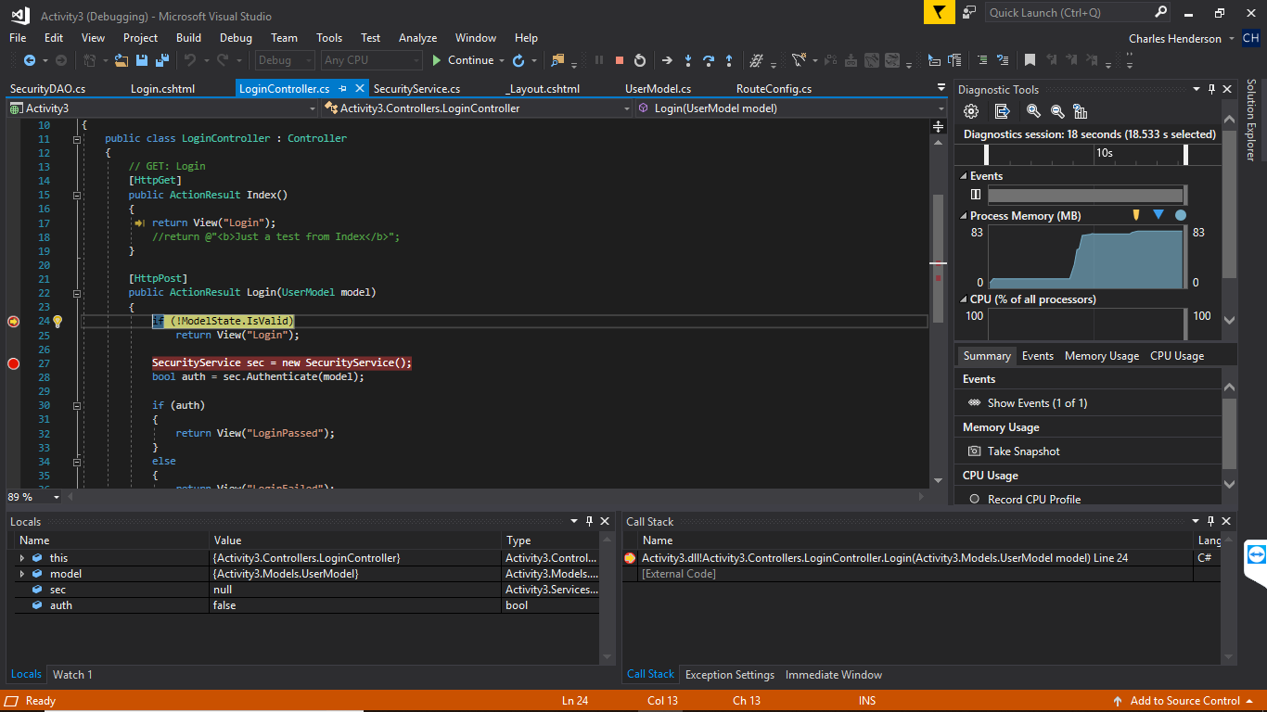

Breakpoint screenshot of Security Service:



Model Passed into test case from webpage: 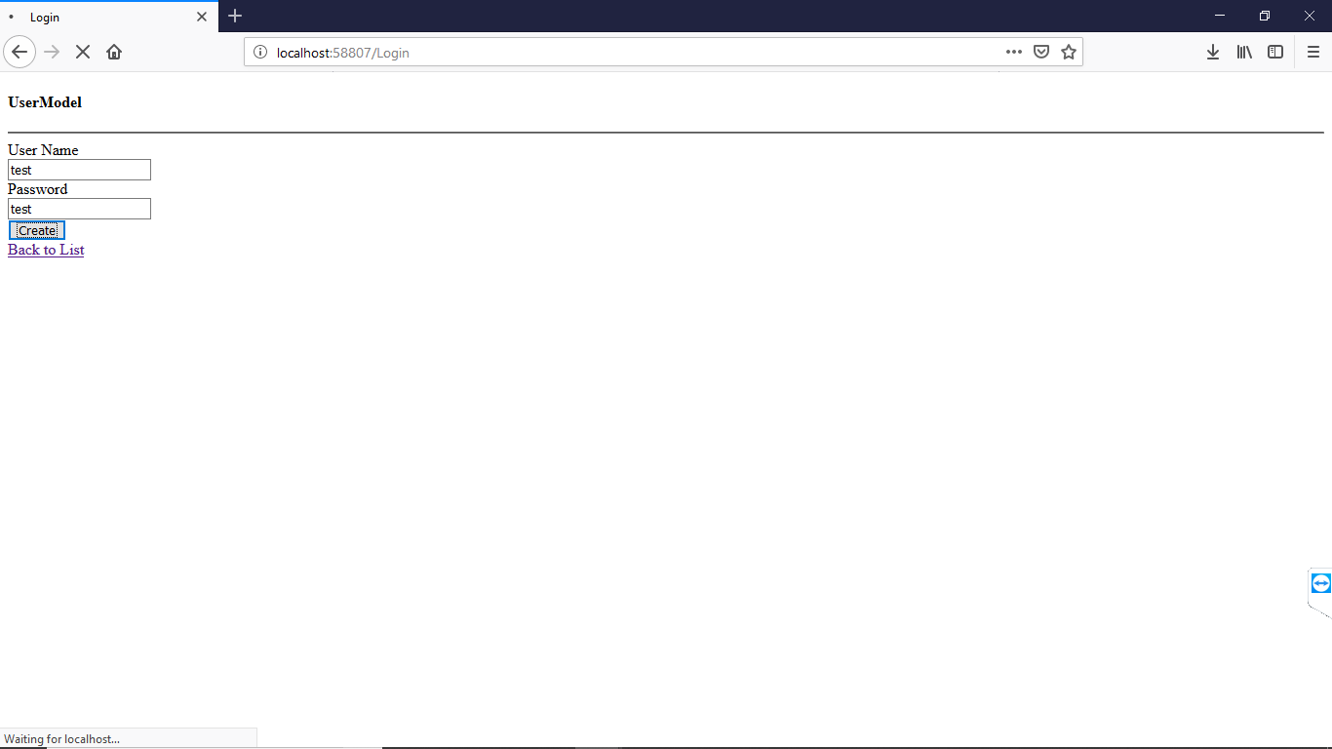

User model passed into argument, and in locals windows as “test” “test”

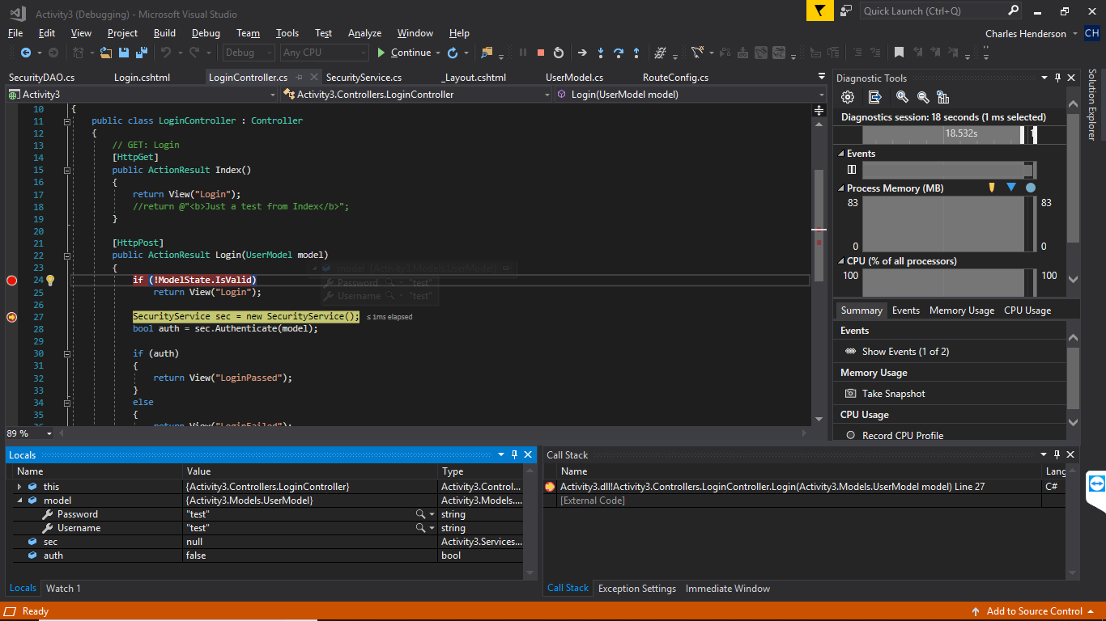

SecurityDAO instance created in Security Service class and iterated to in debugger:

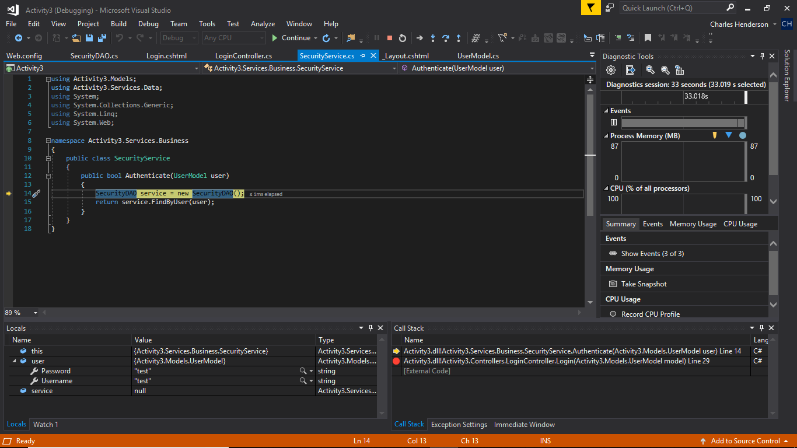

Screenshot of SqlCommand ExecuteReader() in FindByUser which just came from Security Service: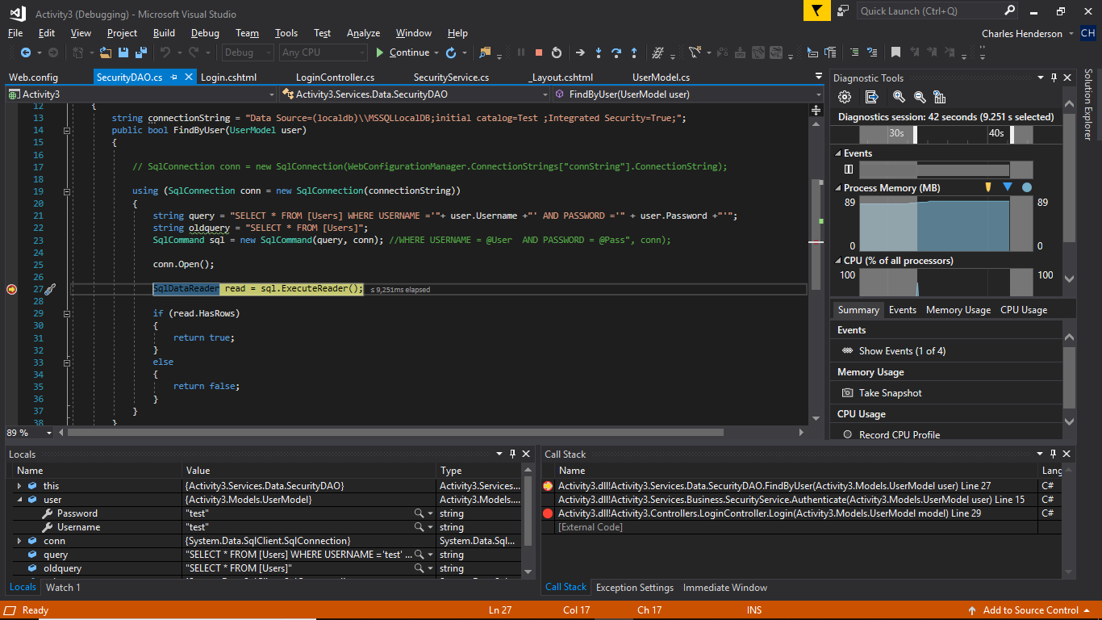

Authenticate then returns true as well:

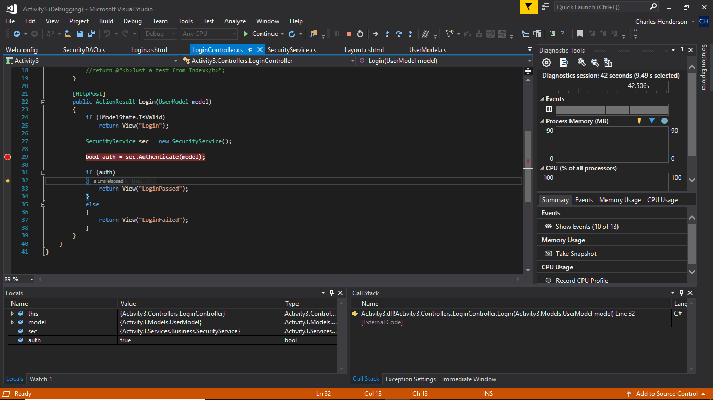

Resulting succesful login! 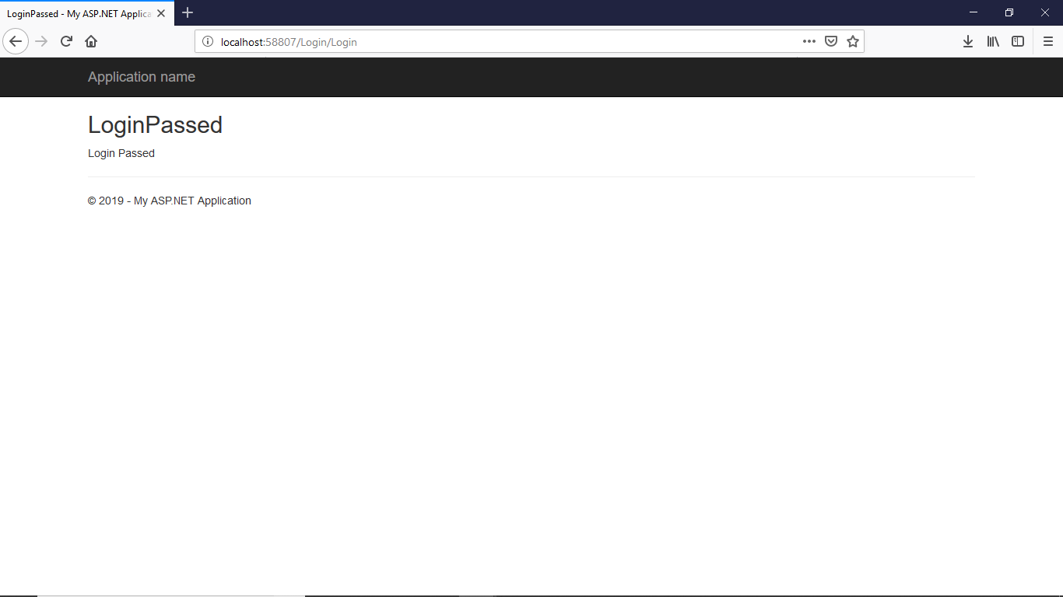

Conditional Breakpoint set in authentication return variable if statement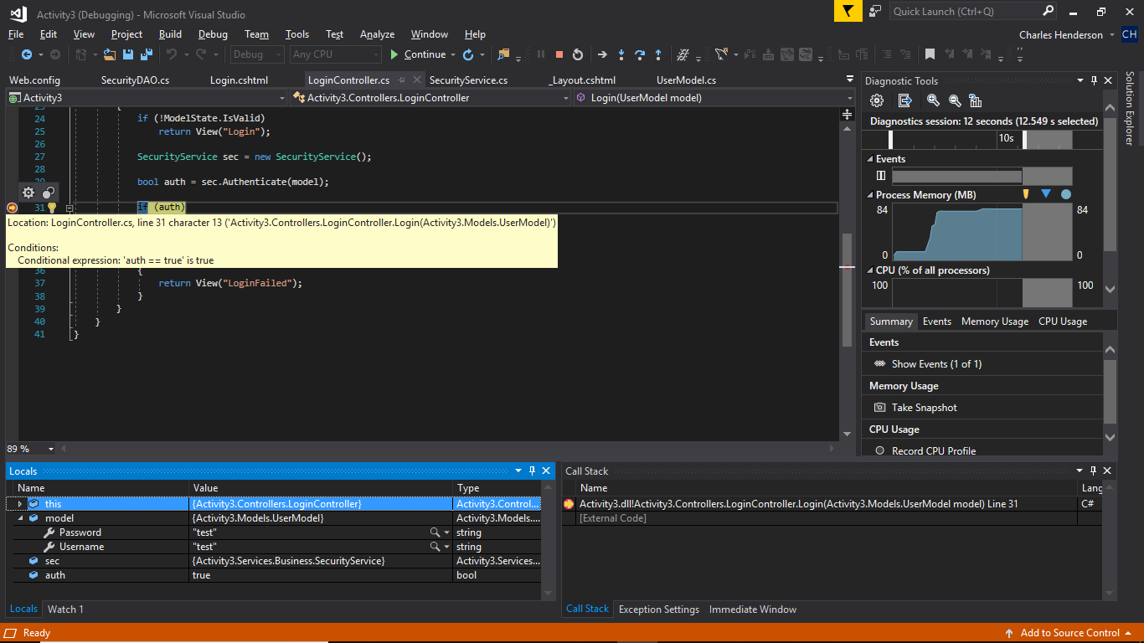

Message, “I am here!” logged in the output when action statement added to breakpoint: 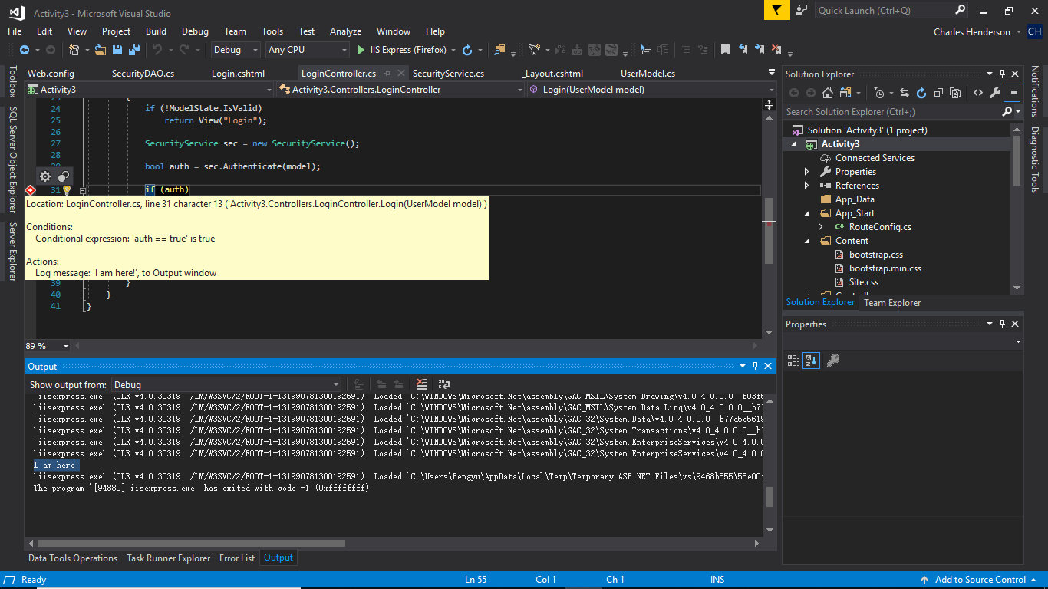

Call stack window highlighted after breakpoint set on FindByUser return statement: 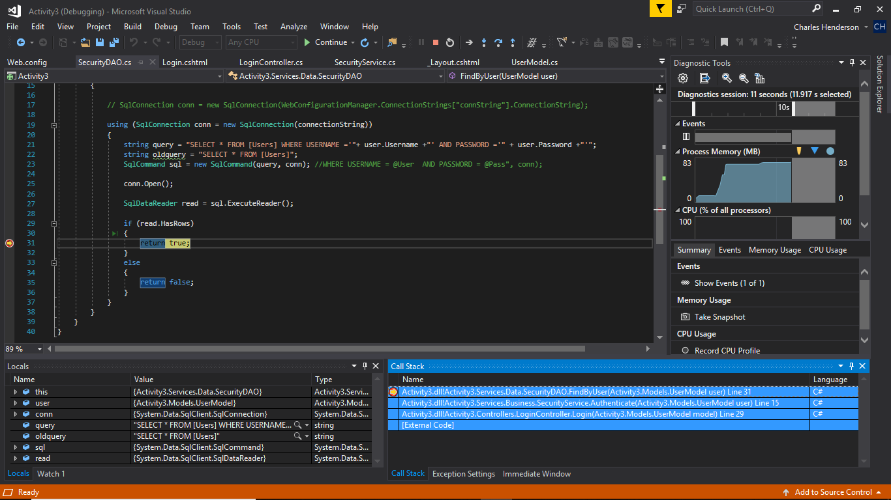

Extra SQL Server DB query screenshot of stored “users”

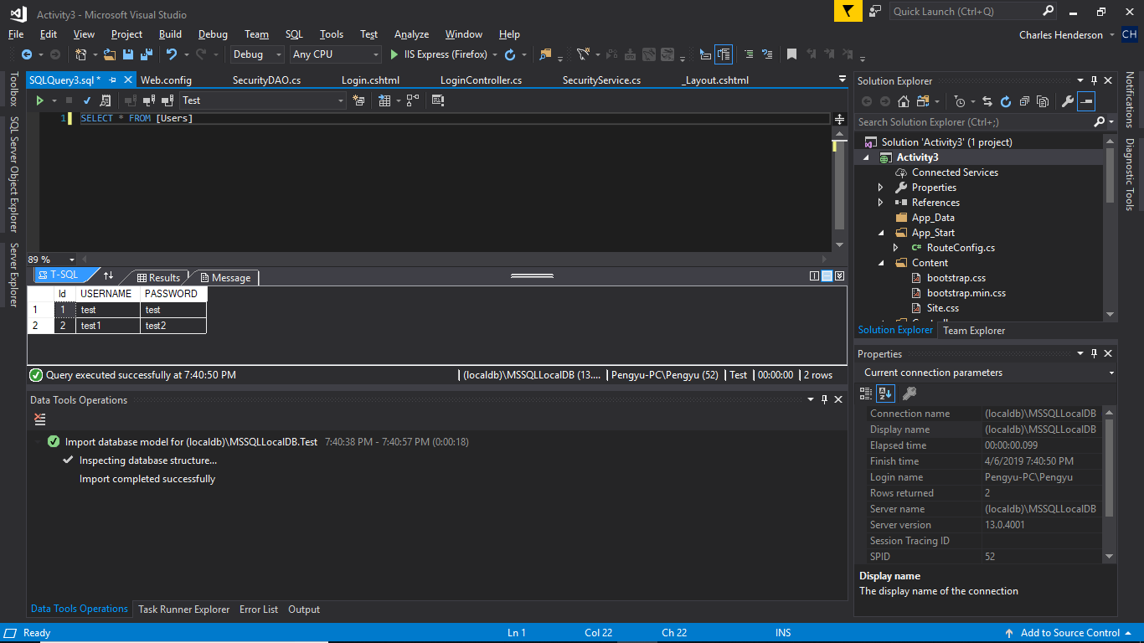

These projects are too large and can’t be uploaded to loudcloud, so the code can be accessed from:

https://github.com/agingdanger/CST-247